**Prerequisites:** Enterprise Structure must be created/setup/assignment before start HR

**SAP HR Overview**

* SAP HR - Introduction
* SAP HR - Maintaining Relationships
* SAP HR - Time Constraints
* SAP HR - Maintaining Infotypes

**Personal Administration**

* **SAP HR - Personnel Administration**
* **SAP HR - Master Data**
* **SAP HR - Infotypes**
* **SAP HR - Personnel Actions**
* **SAP HR - Changing Infotypes**

SAP Human Capital Management (SAP HCM) is one of the key modules in SAP and is also called SAP Human Resource (HR) or SAP Human Resource Management System (SAP HRMS). SAP HCM contains many submodules and all these modules are integrated with each other.

The key modules are as follows −

* **Organizational Management** − Organizational Management includes Personnel development, Personnel cost planning and event management.
* **Time Management** − Time management includes time recording, attendance, time schedule, shift management, etc.
* **Personnel Administration** − Personnel Administration includes personal and organizational structure, Infotypes, integration with time and payroll, etc.
* **Payroll** − Payroll deals with payroll types, payroll group configuration, primary and secondary wages, gross pay, bonus, etc.
* **Recruitment** − Recruitment includes hiring an employee, maintaining HR master data, etc.
* **Training and Event Management** − Training and Event Management deals with identifying training needs, scheduling training, training cost management, etc.
* **Travel Management** − Travel Management includes managing official trips, cost management for travel, travel expenses, etc.

**Organization Management**

Organization Management allows you to manage the enterprise structure and analyze organization plans.

The key features are −

* In organization management, you can configure system settings that is required for enterprise structure, personnel cost planning, etc.
* You can define plan version to configure various organization plans at the same time.
* Only one plan version defines your organizational current plan.
* You can edit, change or compare different organization plans using plan version.
* You can have two different plan versions, one for marketing and other one for sales hierarchy.
* You can compare or edit both the plans but only one plan can be used at a time.

**How to set a Plan version as active?**

There are two ways to set a plan version.

**Step 1** − Use the code **T-Code: OOPV**

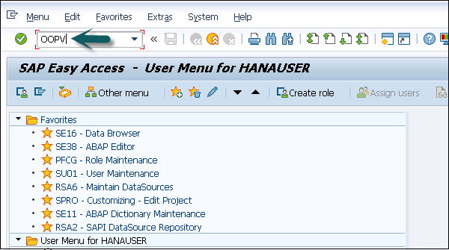

**Step 2** − Go to IMG → Personnel Management → Global Settings → Plan Version Maintenance → Maintain Plan Versions.

You can select from the list of available plans.

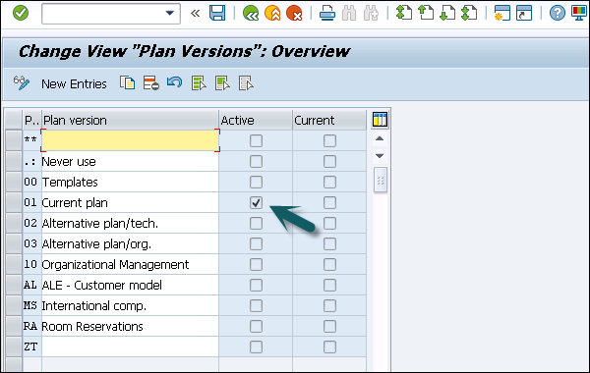

**Organizational Object Types**

An Organization plan consists of various object types, which define the grouping of similar data together. Each object type consists of a unique object key. All object types are linked together with a relationship among each other.

**Example** − A person holding a position that is defined by a specific job.

**Relationship**

In an Organization plan, relationships are used to link different object types.

**Example** − A person holding a position in an organization and is assigned with cost center. It defines Person to position relationship and position to Organization unit.

While defining an hierarchical organization structure, you are creating a relationship between organization objects. When a person is holding a position in an organization unit, it means there is relationship between the position object and the organization object.

**Validity**

It determines the life of object types. At the time of object creation, you enter the start and the end time of the project and this determines the validity of the object.

There are various types of object types that can be defined in an organization plan. Given below are most common object types and their keys −

|  |  |
| --- | --- |
| **Object Type** | **Key** |
| Organizational Unit | O |
| Person | P |
| Cost Center | K |
| Position | S |
| Job | C |

**Key Features of Organization Objects**

The key features are −

* You can create or change an existing object types, which are not managed.

**Example** − Object type person from HR Master Data.

* You can also define the relationship between different object types that should be proposed in the course of the authorization check.
* It is also possible to define an object type hierarchy to generate reporting.
* It is also possible to change the key of standard objects type- "S" for Position, "T" for task.

There are two types of Relationships −

* Relationships with the same object types.
* Relationships with different object types.

**Number Ranges**

You can maintain different number ranges for Organization Management and Personnel administration in SAP HR. As discussed in previous topic, OM contains different object types.

|  |  |
| --- | --- |
| **Object Type** | **Key** |
| Organizational Unit | O |
| Person | P |
| Cost Center | K |
| Position | S |
| Job | C |

To maintain the different number ranges for OM objects, you can use **T-Code: OONR**.

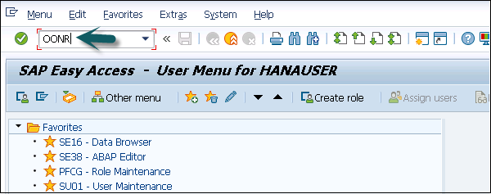

You can also choose the following path.

Go to IMG → Personnel management → Organizational management → Basic settings → Maintain number ranges → set up number assignment for all plan versions → Execute.

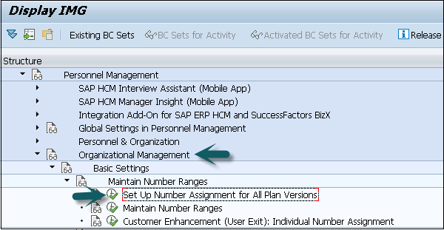

The first two digits represent your plan version and the next two letters represent the object type.

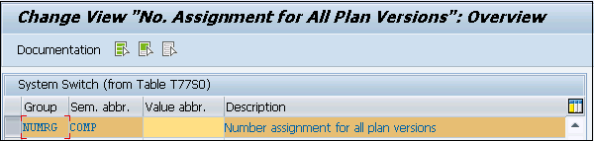

Similarly, you can maintain number ranges for personnel numbers. A Personnel number is generated when an employee is hired. It can be generated internally or externally.

The personnel number range whether internal or external should be defined at the following configuration node.

**Step 1** − **Use T-code: PA04**

**Step 2** − You can also go to SPRO → IMG → Personnel management → Personnel Administration → Basic settings → Maintain number range intervals for personnel numbers.

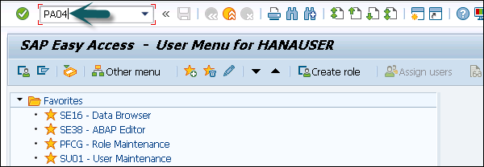

**Step 3** − A new window opens. You will see **Range Maintenance: Human resources**. Go to Intervals to display intervals.

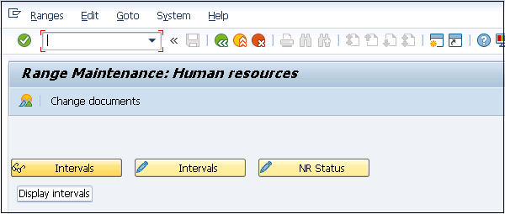

**Step 4** − It will open a new window, **Maintain Intervals: Human resources**. You can check different number ranges for personnel number as shown below −

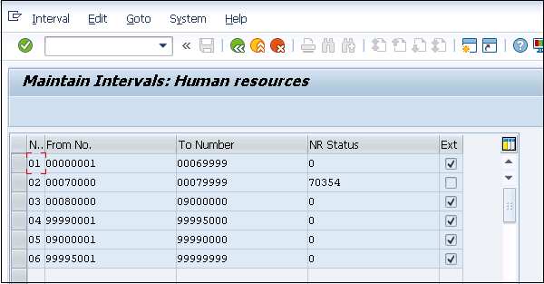

The NR Status indicates the last personnel number assigned/used up for that respective MOLGA. MOLGA Is used to support multi-country human resource management.

# SAP HR - Maintaining Relationships

In an Organization plan, relationships are used to link different object types.

**Example** − A person holding a position in an organization is assigned with cost center. It defines a Person to position relationship and position to Organization unit.

While defining a hierarchical organization structure, it means you are creating a relationship between organization objects. When a person is holding a position in an organization unit, it means there is relationship between position object and organization object.

A relationship can be created in both the ways- top down and bottom approach. These relationships are normally maintained in **HRP001** table. If these relationships are not standard, you may need additional tables.

To maintain relationship, use **T-Code: PP01 or PP03**.

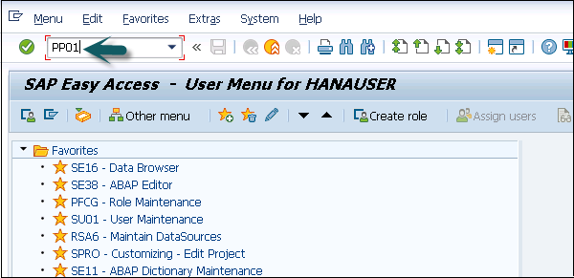

A new window will open with the name **Maintain Object**.

Select the Object type, enter position number, give relationship and click create (F5).

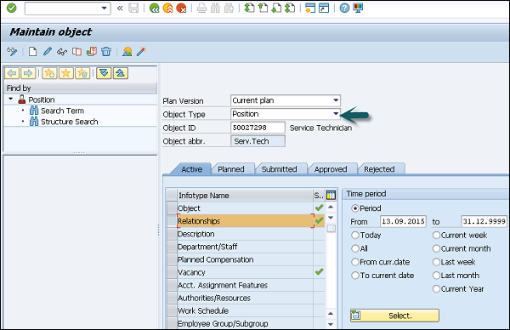

**Object Types and Essential Relationships**

Go to SPRO → IMG → Personnel Management → Organizational Management → Basic Settings → Data model enhancement → Maintain Object Types → Execute

To create new object type and assigning relationships follow the steps given below.

**Step 1** − Create new object type and assign essential relationships.

**Step 2** − Assign object to the required Infotypes.

**Step 3** − Maintain subtypes.

**Step 4** − Maintain personnel actions.

**Step 5** − Assign number range.

**Step 6** − Maintain object via PP03 or PP01.

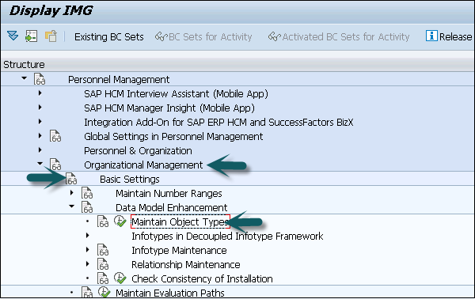

**Step 7** − Go to the **Change View “Object Types”: Overview** window. Click **New Entries** to create a new object type. You can also copy an existing object type.

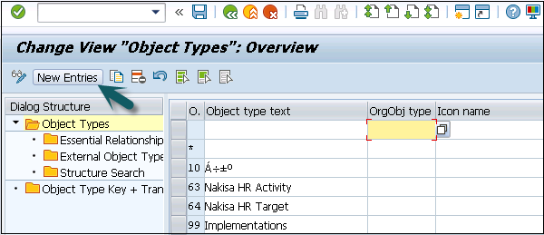

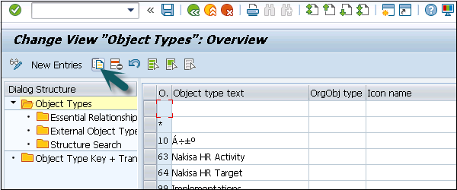

**Step 8** − Enter Object type text, code, etc. When the object is created, assign essential relationships to it by clicking on essential relationships on the left side.

* Assigning a relationship means that once an object is created, the assigned relationships are mandatory to be maintained.
* Maintaining Object types is available in Table: T7780
* Maintaining Essential relationship is available in Table: T7750

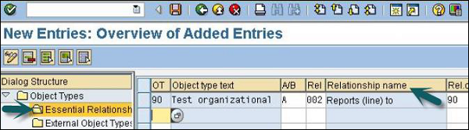

**Relationship Maintenance**

For maintaining relationship in SAP HR module, go to SPRO → IMG → Personnel Management → Organizational Management → Basic Settings → Data model enhancement → Relationship Maintenance → Maintain Relationships → Execute

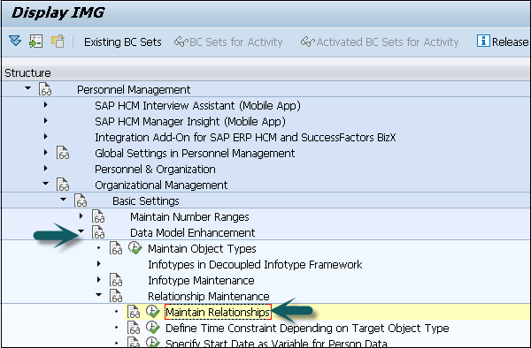

In the left pane, go to **Allowed Relationships**, select the relationship you want to maintain, click **Position**.

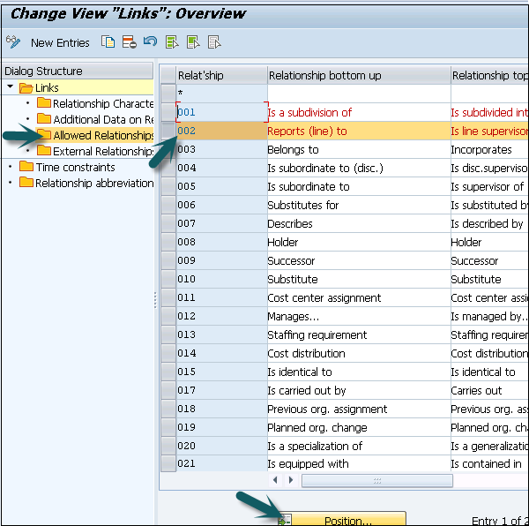

# SAP HR - Time Constraints

Time constraints are used to determine how the object type exists and how they will be updated in the HR system.

You can also define time constraints for object types in Organization management to have a suitable system. You need not to keep orphan object types in the system.

* O - O → Time Constraint 1
* O - S → Time Constraint 2
* O - K → Time Constraint 3
* S - O → Time Constraint 4
* S - P → Time Constraint 5

There are three types of time constraints −

* **Time Constraint 1** is mandatory for a record to exist in the HR system and can exist one at any point of time.
* **Time Constraint 2** is not mandatory for a record but only one exists at any point of time.
* **Time Constraint 3** is not mandatory for a record and can have many at any point of time.

**Assigning Time Constraints to a relation**

**Step 1** − To assign time constraints to a relation, you have to use −

SPRO → IMG → Personnel Management → Organizational Management → Basic Settings → Data model enhancement → Relationship Maintenance → Maintain Relationships → Execute

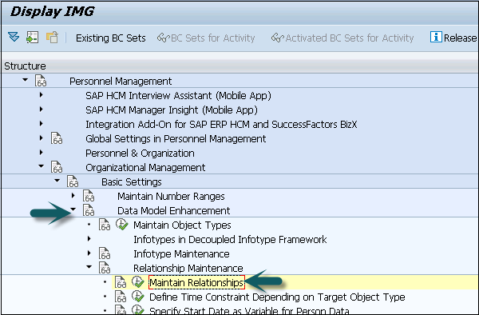

**Step 2** − In the left pane, go to the Time constraint tab as shown in the image given below −

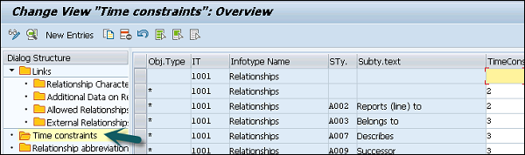

You can assign appropriate time constraints to the given relationship.

Infotypes reactions as per time constraints −

* **Time Constraint 1** − Record must have no gaps, no overlapping. If you select this Time Constraint, there should not be any gaps nor overlapping. This TC is generally used for Infotypes like, 0001, 0008, 0009 etc. where there is only one valid record.
* **Time Constraint 2** − This TC includes those records that can include gaps but there should be no overlapping. If you select this TC, it means that you can have gaps but NO overlapping. Consider an example of the marital status of an employee. The employee has a spouse but a gap can occur in case he is divorced.
* **Time Constraint 3** − This TC includes records that can have gaps and can exist multiple times. For example, Infotype IT0014 can have multiple records in that particular Infotype at the same time with overlapping.

**Maintaining Personnel Actions**

In SAP HR system, personnel actions are performed for all the Infotypes that require data to be entered in the HR system. Common Infotypes that require a personnel action are hiring a new employee, termination of an employee, etc.

**Step 1** − To perform a Personnel action, use T-Code: **PA 40** or go to SPRO → IMG → Personnel Management → Personnel Administration → Customizing Procedures → Actions.

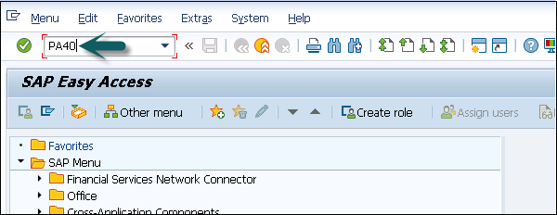

**Step 2** − A new window ‘Personnel Actions’ opens.

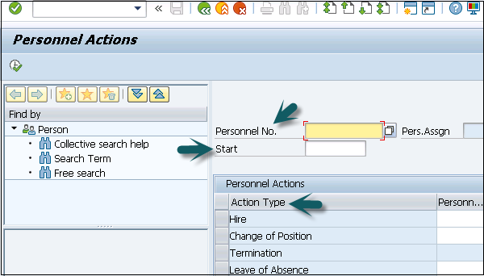

The screen consists of the following fields −

* **Personnel No** − This field has an employee’s personnel number. When a new employee is hired, it is generated automatically by the system.
* **Start** − This field shows the start date of the personnel action.
* **Action Type** − In this field, you have to select the action type that needs to be performed.

**Example**

Let us understand how a new employee is hired in SAP HR system.

**Step 1** − Enter the hiring date as shown below.

**Step 2** − From Action type, select **Hire**.

**Step 3** − Click the **Execute** button given on top.

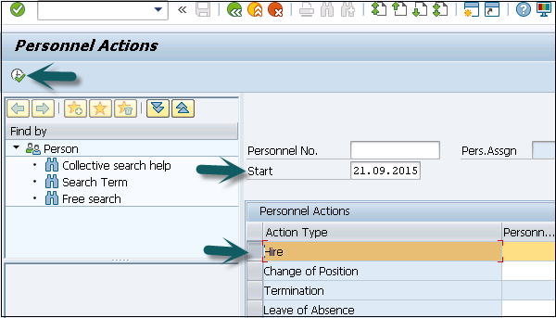

A new window will open. Enter details like Reason for action, Personnel area, Employee group and sub group, etc. and click the Save icon at the top.

# SAP HR - Maintaining Infotypes

In SAP HR system, Infotypes are used to store the data for all the personnel actions and administrative tasks in the system. Infotypes are known as small units of information in SAP HR system.

Infotypes group the similar data together and define structure, enter data and define the information for specific period of time.

**Components of Infotypes**

An Infotype consists of the following components −

**Structure**

An Infotype contains a set of similar data records in the form of data structure. Infotype contains series of information like first name, last name, date of birth, marital status, etc. When an Infotype is updated in the system, old data is not removed from the system but time is delimited.

**Data Entry**

You can enter predefined values for Infotype that helps in fetching and maintaining the data in the system. Entries in HR system are checked automatically for accuracy. Default value checks depend on the employee organization assignment.

**Time Dependency**

When an Infotype is updated in the system, old data is not erased. It is stored in the system for historical evaluation purpose. This allows each Infotype to have multiple records but all the records may vary as per their validity.

Time based reaction of Infotype is defined in the Time constraint field. Infotype 0000 to 0999 are Personnel Administration Infotypes. It is also possible to define permissibility of Infotype for each country, this allows you to restrict Infotype while editing the master data.

Go to SPRO → IMG → Personnel Management → Personnel Administration → Customizing Procedures → Infotypes → Assign Infotypes to Countries

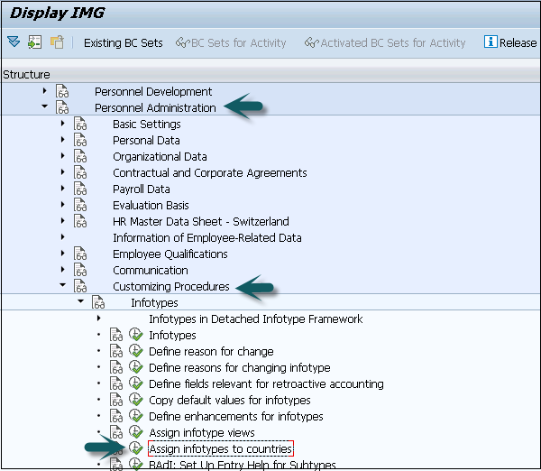

**How to Maintain Infotypes?**

To maintain Infotype, follow the steps given below −

**Step 1** − Go to SPRO → IMG → Personnel Management → Organizational Management → Basic Setting → Data model enhancement → Infotype Maintenance → Maintain Infotypes → Execute.

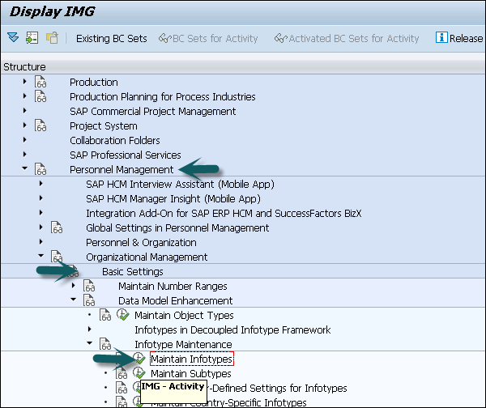

**Step 2** − Select the Infotypes to which the newly created custom object needs to be assigned. Select the Infotype and click the **Infotypes per object type** option.

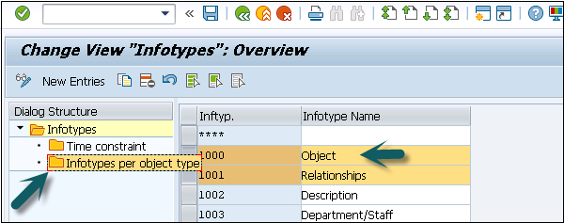

**Step 3** − To assign custom objects to Infotype, click the **New Entries** option. You can uncheck the **No Maintenance** check box such that you can maintain custom objects via Organization Management transactions **PP01**.

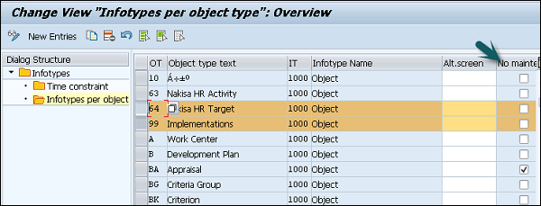

**Maintaining Info Subtypes**

Info Subtypes are known as sub units of an Infotype. Using subtype, you can easily manage and access the data in HR system and can control the Infotypes. You can easily assign different features to control the data like time constraints to sub types.

You can assign different control features to sub types as per requirement like TC1, TC2, and TC3.

**Example**

Consider the example of an Infotype Addresses (0006). Following are the subtypes −

* **Subtype 1** − Permanent Residence address
* **Subtype 2** − Temporary address
* **Subtype 3** − Home address

Considering Control feature – Time constraint for this Infotype, you should use TC-3 for Infotype Addresses, as we need to pass multiple values. Permanent Residence address subtype should be Time Constraint -1. Home address can exist once at any one time, hence it is Time Constraint -2.

**How to maintain subtypes?**

To maintain subtypes −

**Step 1** − Go to SPRO → IMG → Personnel Management → Organizational Management → Data model enhancement → Infotype Maintenance → Maintain subtypes → Execute.

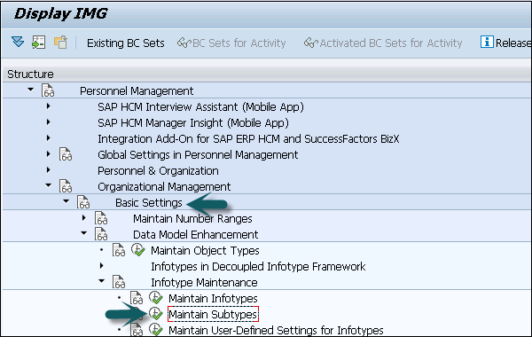

**Step 2** − To maintain subtype, select the subtype in the next window. In the left pane, you have an option to add control feature - Time Constraint.

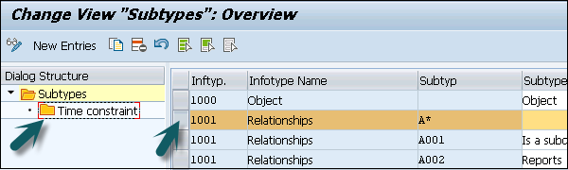

**Step 3** − Double click the Time constraint in the left pane, a new window ‘Change View “Time Constraint”: Overview’ will open.

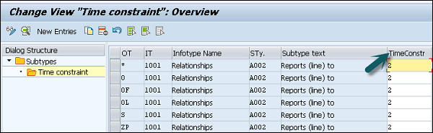

# SAP HR - Personnel Administration

SAP HR - Personnel administration consists of many individual pieces of information, which are stored, updated and managed for each employee in HR system.

To manage personnel data related to tasks in HR system, you need Personnel Administration. There are various Infotypes that can be used for Personnel Administration.

Commonly used Personnel Administration Infotypes are −

* Organization Management Infotypes
* Time Management Infotypes
* Recruitment Infotypes

## Organization Structure

Organizational structures is used in HR to plan and map the organizational levels of an organization to control and simplify processes such as time recording and payroll. Typical components in an organizational structures include −

* Enterprise structure
* Pay scale structure
* Wage types
* Personnel structure
* User authorizations

In Organization hierarchy, you define the subdivision of company into personnel areas, sub areas, company code, etc. Using different grouping, you can create organizational hierarchies and control functions. Using grouping, you can set up enterprise and personnel structure that are independent of each other.

By assigning an employee to personnel and enterprise structure, you can easily process human resource data of an employee. By using the default values, it is easy to manage data for different fields.

To evaluate human resource data, you can use the Organizational structures for creating evaluations and analyses of employee data for Controlling and departments.

## Enterprise Structure

Enterprise structure of an organization is defined as structure to manage Personnel administration, payroll processing, and time management for a company. Enterprise structure defines the key components in a company and their relationship with each other.

Key components in an Enterprise Structure include −

* Client
* Company Code
* Personnel area
* Personnel subarea
* Organizational Key

The enterprise structure in "Personnel Administration" consists of the following −

### Client

A client is known as an organizational and data technical isolated unit in SAP ERP system and each unit has separate master records and its own separate record of tables.

### Company code

It is called the smallest organizational unit of external accounting in which a complete and isolated financial accounting can be created. Example: Profit and loss calculation, balance sheets are contained within the company code organizational units.

### Personnel area

The personnel area is used in Personnel Administration in HR system and is unique within a client.

Important features are −

* A Personnel area is subdivided into subareas.
* Organizational data and steps to assign it are stored on a personnel area and subarea. The guidelines can include pay scale, legal or collective agreement, etc.
* A personnel area is assigned to the company code to manage financial accounting values.
* A pay scale area, a pay scale type and a public holiday calendar are precisely defined for a personnel subarea.

### Personnel subarea

The personnel subarea is used only in Personnel Administration in SAP ERP. The groupings linked to the personnel subarea determine which entries from the subsequent screen are allowed for an employee of a particular company code.

**Example** −

The personnel area in a software company can be subdivided into development, training and administration personnel subareas.

Groupings are used for validation of master and time data. Groupings are also used to check the plausibility of data that you enter.

### Organizational key

Using an Organizational key, you can define the organizational assignment more precisely. An organizational key can consist objects from enterprise structure and personnel structure.

## Personnel Structure

Personnel structure is used to define an employee’s position in an organization. Personnel structure can be divided into two parts −

* Administrative Structure
* Organizational Structure

### Administrative Personnel Structure

It consists of the following objects −

* Employee group
* Employee subgroup
* Payroll area
* Organizational Key − Organizational key consists of both personnel and enterprise structure. Employee group and subgroup can also participate while defining an Organizational key.

### Organizational Personnel Structure

It consists of the following elements −

* Position
* Job
* Organizational unit

To assign an employee to the Personnel structure, use hiring as personnel action as mentioned in the previous topic. This is stored in Organizational Infotype 0001.

## Hiring an Employee

To perform a Personnel action, follow the steps given below −

**Step 1** − Use T-Code: PA 40 or go to SPRO → IMG → Personnel Management → Personnel Administration → Customizing Procedures → Actions.

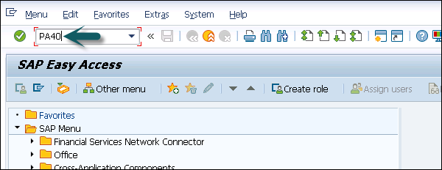

**Step 2** − A new window Personnel Actions opens.



It consists of the following fields −

* **Personnel No** − This field has an employee’s personnel number. When a new employee is hired, it is generated automatically by the system.
* **Start** − This field shows the start-date of the personnel action.
* **Action Type** − In this field, you have to select the action type that needs to be performed.

**Step 3** − The next step is to enter the hiring date as shown below. From the menu of Action type, select Hire. Click the Execute option at top.

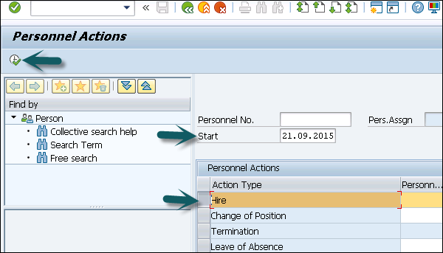

**Step 4** − In the next window, enter the details like Reason for action, Personnel area, Employee group and sub group, etc. and click the Save icon at the top.

# SAP HR - Master Data

Maintaining the HR Master Data function allows you to maintain employee data tasks like entering the data, update, etc.

Data related to an employee is entered in various Infotypes. For example, Infotype 0002 contains personal information of an employee like name, date of birth, marital status, etc. Infotypes are used to group similar data and makes it easier to process.

Maintaining HR Master Data function allows you to access an employee’s Infotype records individually. Similarly, you can use fast entry function to maintain employee data simultaneously for multiple employees.

Performing a Personnel action in HR system like hiring an employee, involves entering huge data in the system. You have to enter series of Infotype information related to an employee.

## HR Master Data Structure

The key components for HR Master Data in SAP Human Capital Management system are as follows −

* Information type or known as Infotype
* Information subtype or known as Info subtype
* Object Identification to differentiate between data records
* Data structure elements characteristics
* Relationship

## Processing HR Master Data

There are many functions, which can be used to process HR master data in system. These allow you to create or edit the existing records in the system.

### Create function

The **Create function** allows you to enter the new Infotype record in the system. You can create new Infotype record and in addition, retain the old records in the system. Validity of new record is defined.

### Change function

The **Change function** is used to edit an existing Infotype without creating a new Infotype. Using the change function, the previous value of Infotype is changed and any previous value is not stored.

### Delete function

The Delete function allows you to delete an Infotype record in the HR system. When you delete an Infotype record with time constraint 1, it extends the previous record automatically.

### Copy function

The Copy function allows you to create a new Infotype record and update history. This function does not enter data on a new screen but asks to enter information on a screen containing the data.

### Display function

You can use the Display function to view an Infotype on the screen. In display mode, you cannot process or update data.

Using the List function, you can display an overview of all the records stored for a specified Infotype.

## Selecting HR Master Data

To access an employee data, you must enter the employee’s personnel number and the Infotype whose data records you want to process. You can find personnel numbers, even if you do not know them exactly, by using the Search Help for Personnel Numbers.

Once you search an employee, you can check the employee Infotype record in the system. Infotype search can be performed using the following methods −

* **Selecting an Infotype by name or number** − You can perform a search for an Infotype if you know its name or number.
* **Selecting an Infotype using functional area** − You can also search an Infotype using functional area as SAP HCM system contains similar Infotypes group together.
  + Personal Data
  + Payroll Data
* **Selecting Infotype using text** − You can also search an Infotype by typing text search term. System displays all the Infotype whose name matches the search item.
* **Selecting an Infotype using Personnel file** − You can also search an Infotype using a personnel file.

# SAP HR - Infotypes

Infotype is used to store personal data about an employee. An Infotype contains four digit code and name of Infotype.

**Example** − Infotype 002 contains employee personal data- like name, date of birth, marital status, etc.

Each Infotype has two fields −

* **Mandate fields** − A tick mark sign in the field box represents these fields.
* **Option fields** − These fields are not mandatory and can have a blank value.

There are predefined number ranges that SAP has defined for Infotype.

* HR and Payroll Data Infotype → 0000 to 0999
* Organizational Data → Infotype 1000 to 1999
* Time Data → Infotype 2000 to 2999

You can further divide an Infotype into groups, which are called subtypes. For example, an Infotype Address, Infotype 0006 can be divided into subtypes - Permanent Residence and Emergency address.

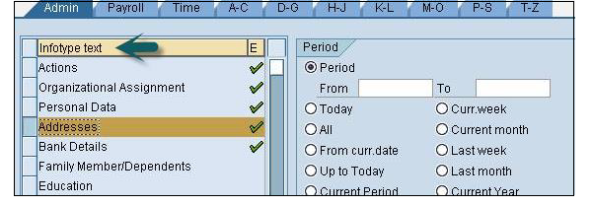

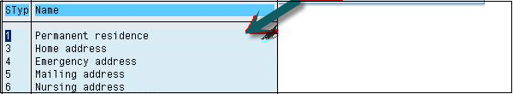

## Creating an Infotype

To create an Infotype follow the given steps −

**Step 1** − Use T-code: PA30.

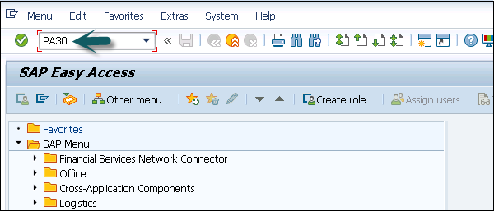

**Step 2** − A new window **Maintain HR Master Data** opens. Enter the personnel number and press Enter.

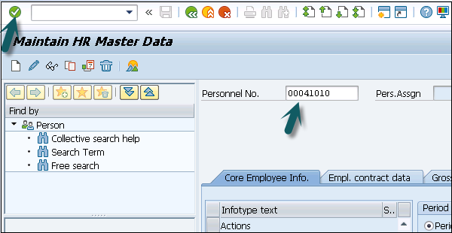

**Step 3** − Enter the Infotype you wish to select for a new record and click the Create button.

In the Period section, select the start and the end date for an Infotype.

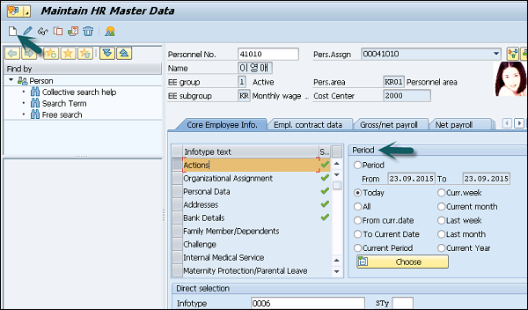

**Step 4** − In the next window, select Personnel action. Once you enter all the details click Save.

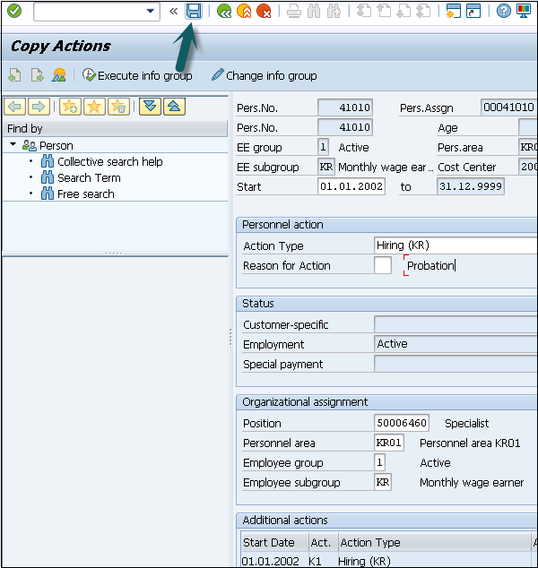

## Display an Infotype

You can search an Infotype by its name or number.

**Step 1** − Search an Infotype using Personnel number and T-code: PA30 or PA20.

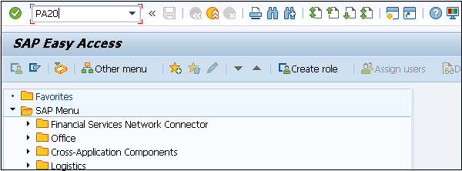

**Step 2** − In the new window, enter the personnel number and press Enter.

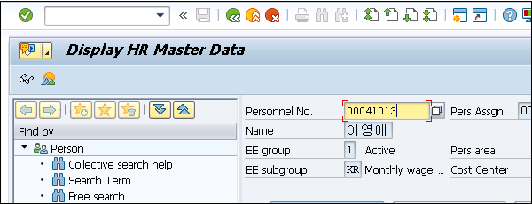

**Step 3** − Select the Infotype you want to display. Click F7 or the icon at the top.

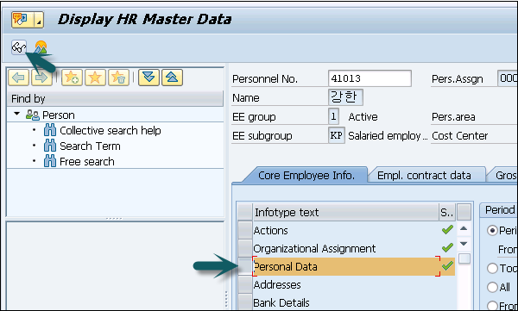

**Step 4** − In the new window, all the fields will be deactivated and you will see the details of the selected Infotype.

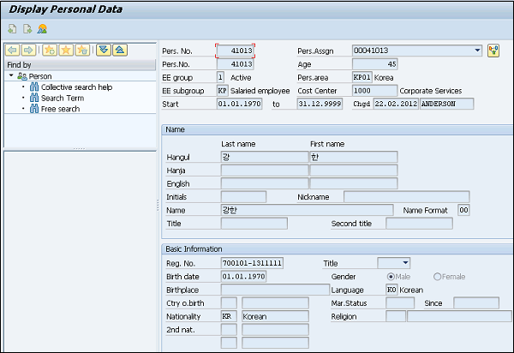

**Step 5** − Similarly, you can copy or change an existing Infotype using T-code: PA30.

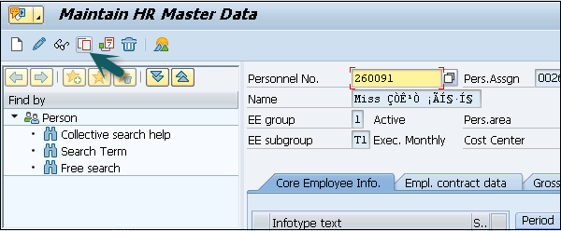

## Delete an Infotype

To delete an Infotype, follow the steps given below.

**Step 1** − To delete an Infotype, use the same T-code: PA30.

**Step 2** − Enter the Personnel number and select the Infotype you want to delete.

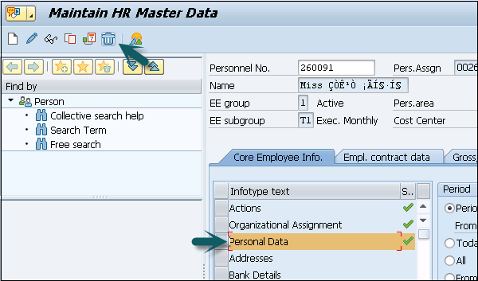

**Step 3** − In the next window, you will see a summary of data that will be deleted. Click Delete.

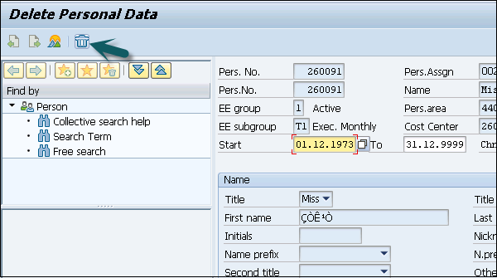

# SAP HR - Personnel Actions

In SAP HR system, personnel actions are performed for all the Infotypes that require the data to be entered in HR system. Some common Infotypes that require a personnel action are hiring a new employee, termination of an employee, etc.

To perform a Personnel action follow the steps given below −

**Step 1** − Use T-Code: PA 40 or go to SPRO → IMG → Personnel Management → Personnel Administration → Customizing Procedures → Actions.

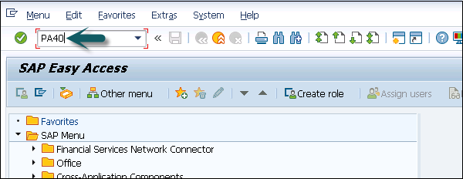

**Step 2** − A new window ‘Personnel Actions’ opens.

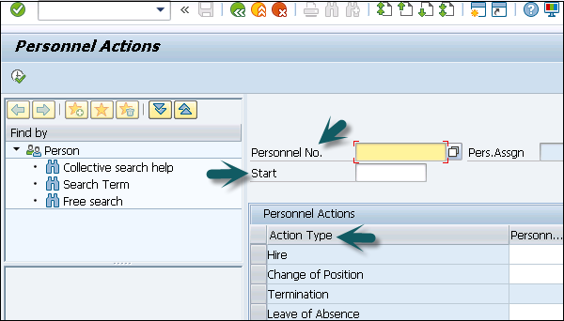

The screen consists of the following fields −

* **Personnel No** − This field has an employee’s personnel number. When a new employee is hired, this is generated automatically by the system.
* **Start** − This field presents the start date of the personnel action.
* **Action Type** − In this field, you have to select the action type that needs to be performed.

**Example**

Let us understand how a new employee is hired in a SAP HR system.

**Step 1** − Enter the hiring date as shown in the image given below. Under the Action type, select Hire. Click the Execute option at the top.

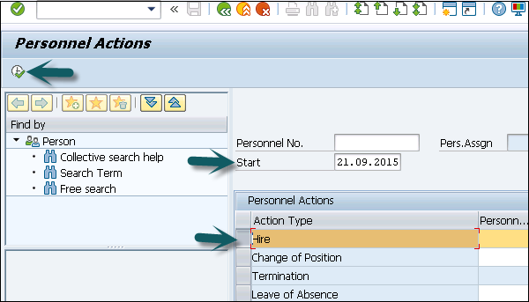

**Step 2** − In the new window, enter the details like Reason for action, Personnel area, Employee group and sub group, etc. and click the Save icon at the top.

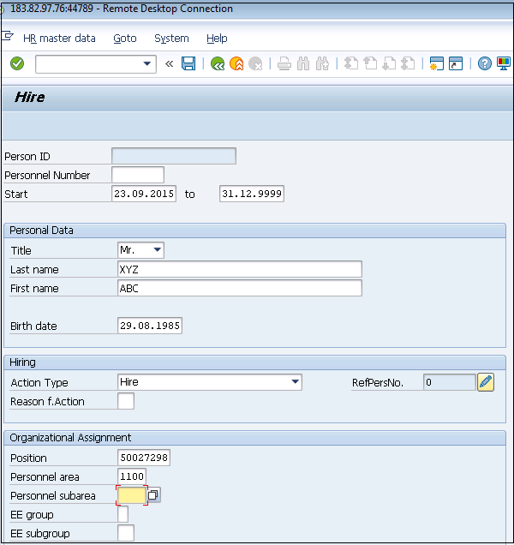

## Building Enterprise Structure

The components that define a company’s enterprise structure for Personnel administration are −

* Defining Company code
* Defining Personnel area
* Defining Personnel Subarea

To create a company follow the steps given below −

**Step 1** − Go to SPRO → IMG → Enterprise Structure → Definition → Financial Accounting → Define Company.

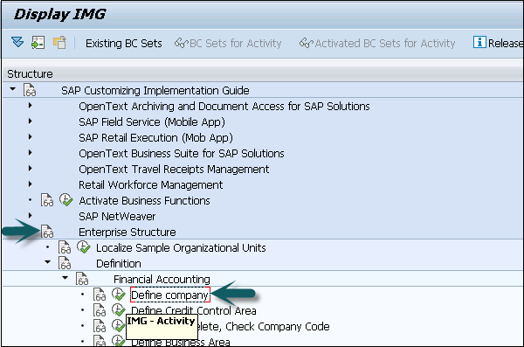

**Step 2** − In the new window, Click New Entries.

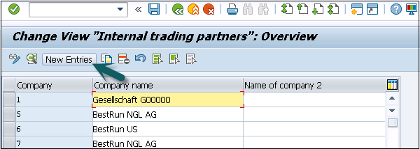

**Step 3** − Enter the details like Company, Company Name, Address as shown below −

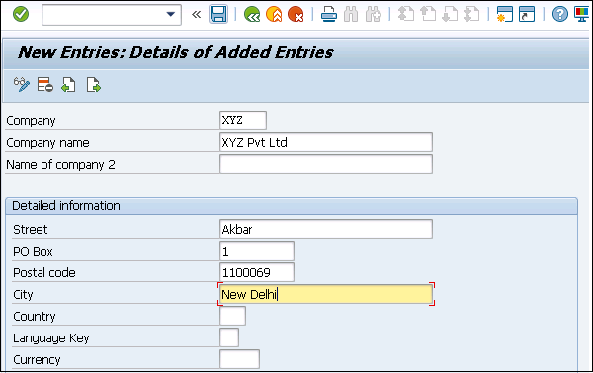

**Step 4** − Click the Save icon at the top.

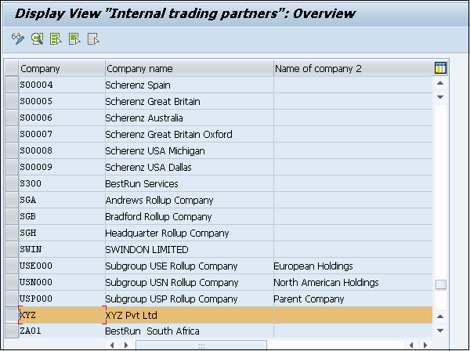

## Editing Company Code Data

To edit company code Data −

**Step 1** − Select Edit Company code data.

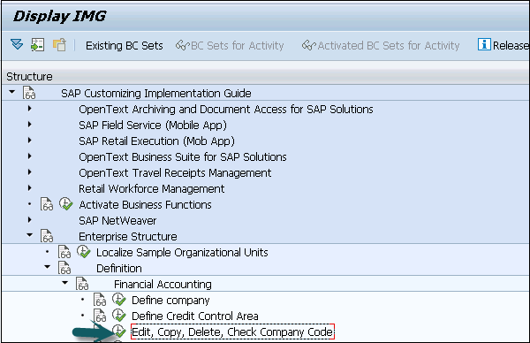

**Step 2** − Click on New Entries.

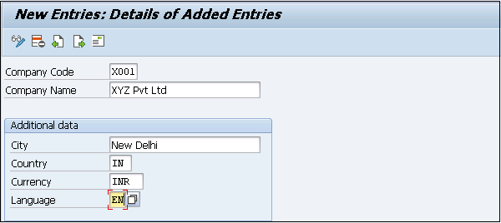

**Step 3** − Click the save icon at the top.

Data Saved

## Assigning a Company Code

To assign a company code to a company follow the steps given below −

**Step 1** − Go to SPRO → IMG → Enterprise Structure → Assignment → Finance Accounting → Assign Company Code to Company → Execute.

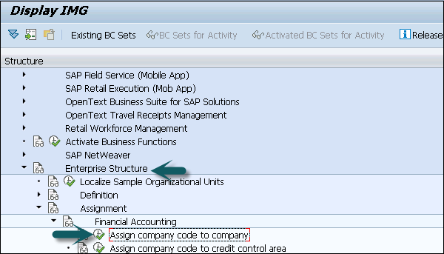

**Step 2** − Change the company code in the new window.

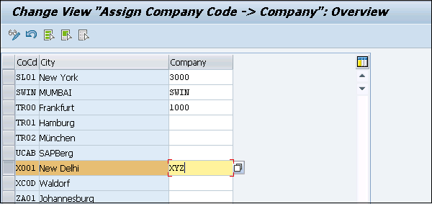

## Creating Personnel Areas

To create Personnel Areas follow the steps given below −

**Step 1** − Go to SPRO → IMG → Enterprise Structure → Definition → Human Resource Management → Personnel areas.

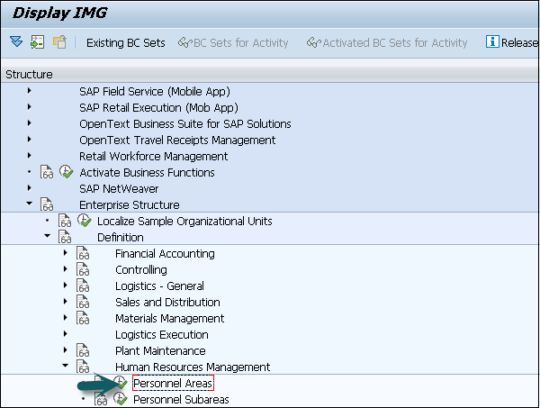

**Step 2** − Go to New Entries and fill the details. Click the save icon at the top.

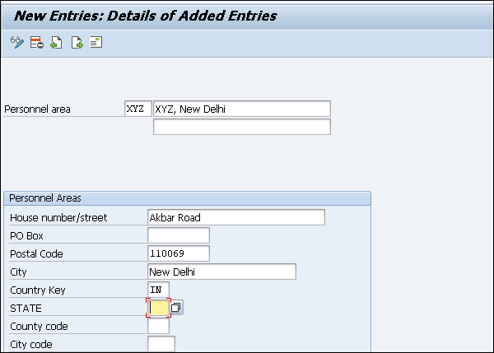

**Step 3** − Personnel areas are created.

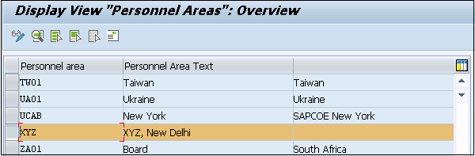

## Assigning Personnel Area to Company Code

To assign Personnel Area to Company Code follow the steps given below.

**Step 1** − Go to Assignment → Human Resource Management → Assignment of Personnel Area to company code.

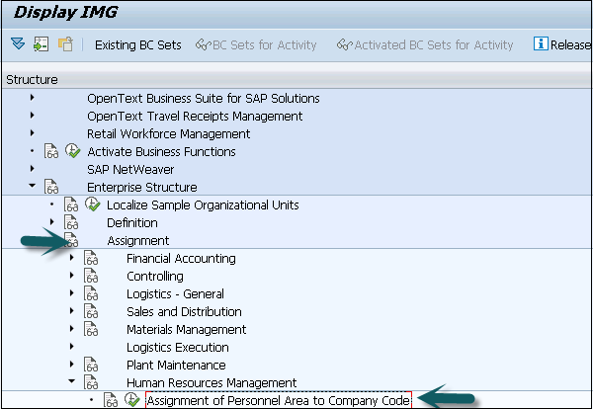

**Step 2** − Enter the company code for Personnel area as created earlier.

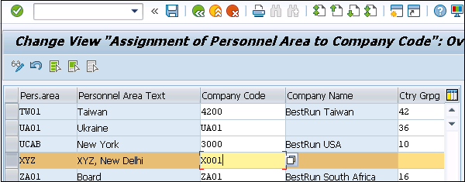

**Step 3** − Click the save icon.

Data Saved

# SAP HR - Changing Infotypes

As SAP provides various Infotypes that are grouped together for different information groups. Sometimes you need to modify the standard Infotypes as per business requirement.

Customization of Infotypes can be done by hiding standard Infotypes fields as per business requirement or you can also add custom Infotype fields in the structure.

Following are the fields that can be used to configure the Infotype screen −

|  |  |  |
| --- | --- | --- |
| **Field** | **Field Name** | **Field Length** |
| Subtype | SUBTY | Up to 4 characters |
| Company code | BUKRS | 4 characters |
| Screen number | DYNNR | 4 characters |
| Payroll area | ABKRS | 2 characters |
| Employee group | PERSG | 1 character |
| Country grouping | MOLGA | 2 characters |
| Personnel area | WERKS | 4 characters |
| Employee subgroup | PERSK | 2 characters |

These are fields, which are used to maintain the screen layout and are maintained using the T-code: PE04.

**Step 1** − Go to SPRO → IMG → Personnel Management → Personnel Administration → Customizing User Interface → Change Screen Modifications → Execute.

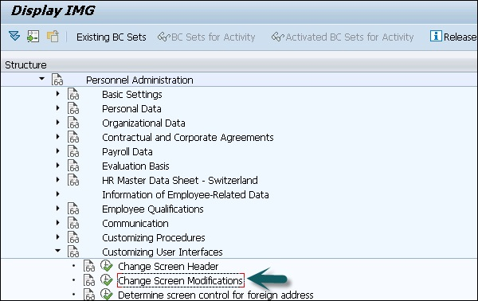

**Step 2** − In the next window, you will see all Infotype screen controls like Mod. Pool, Screen, Feature, Variable key, etc. To create a new control, click the tab New Entries.

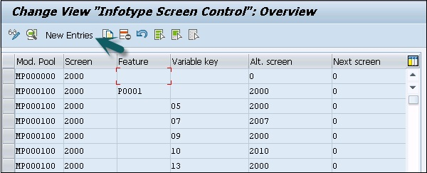

**Step 3** − In the new window, enter the values as shown below and press the ENTER key.

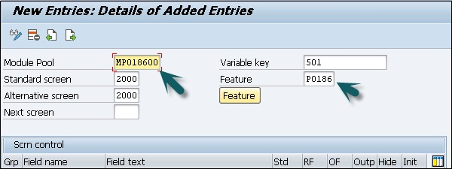

**Important** −

* Module Pool is MPxxxx00, xxxx represents Infotype no.
* Variable key is what is returned by your feature.
* Standard Screen will be always 2000.
* Feature will be Pxxxx, where xxxx is your Infotype no.

Once you press ENTER, it will show you all the fields of this Infotype. In screen control, you will see five radio buttons against each entry. These radio buttons include −

* **Std means Standard setting** − When you select this option, the field characteristics correspond to the standard setting.
* **RF means Required field** − Select this check box to define the screen field as a required field.
* **OF means Optional field** − Select this option to define the field as an optional field.
* **Outp means not ready for input** − This can be selected to mark the field. It is an output field only and is not used for input.
* **Hide means hiding a field** − This option is selected to hide the screen field.
* **Init means hide and Initialize** − If this option is selected, the screen field is hidden.

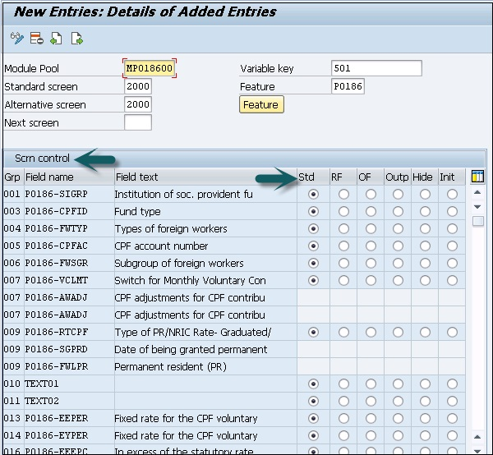

**Step 4** − To save this setting click the Save icon at the top.

Save Setting

**Step 5** − Click the Feature button; you can add values for subtypes.

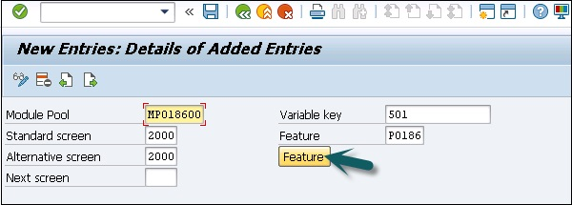

**Step 6** − This will take you to the initial screen of Features. Click Change to change the values.

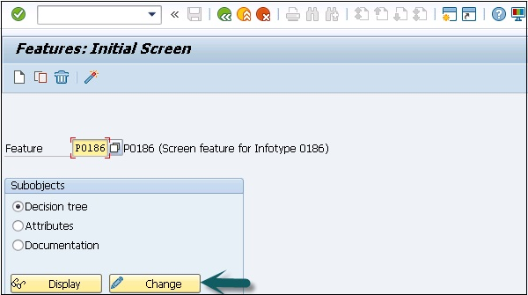

**Step 7** − To create a new subtype node, click Create.

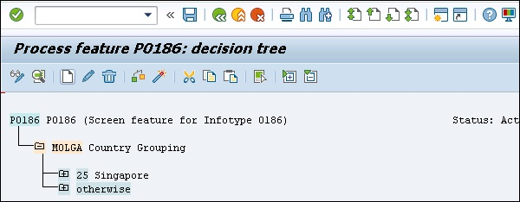

**Step 8** − Select the subtype and click Create. Select the Return Value and press ENTER.

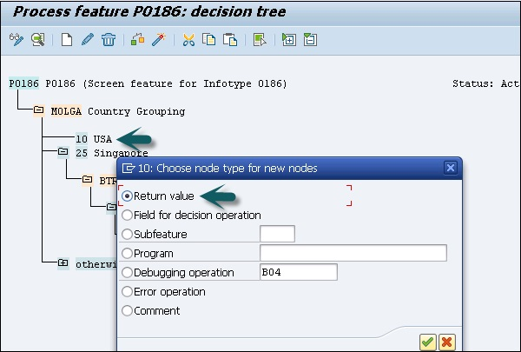

**Step 9** − Enter the Return value as Variable key -501 and click Transfer.

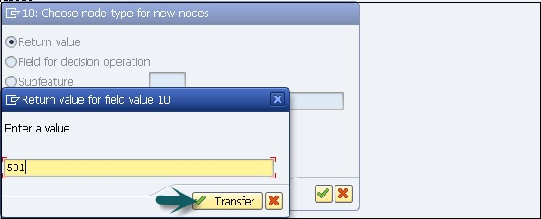

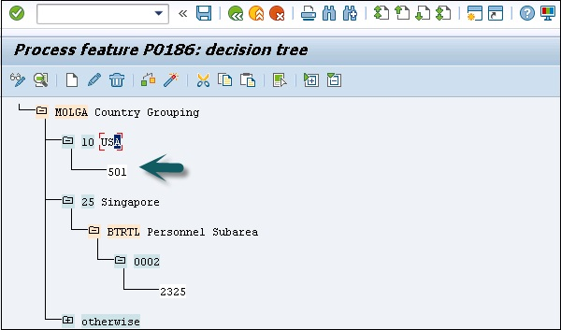

**Step 10** − Click Save and press the activate icon at the top.

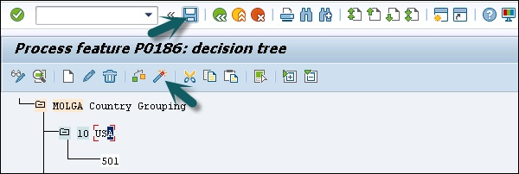

## Integration with Time & Payroll

The integration between time management and payroll is performed through time evaluation. It allows you to determine the wages of an employee using time-wage types determined by time evaluation.

The time wage types in tables ZL, ALP, and C1 (Cluster B2) represent the interface between time evaluation(TM) and payroll.

* **ZL** − Contains wage types
* **C1** − Contains data for cost account assignment
* **ALP** − Contains the specifications on a different rate of payment

The integration of TM with other components can be found in the following IMG path.

SPRO → IMG → Time Management → Integrating Time Management with other SAP Applications.

